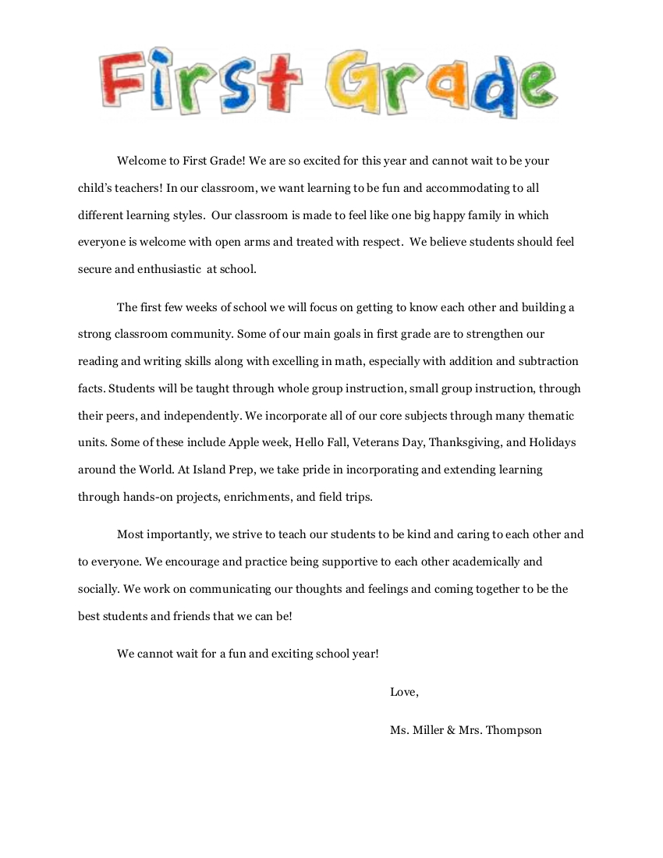

**Welcome to First Grade! I am so excited for this year and I cannot wait to be your child’s teacher! In the classroom, I want learning to be fun and accommodating to all different learning styles. The classroom will feel like one big happy family in which everyone is welcome with open arms and treated with respect. Our scholars should feel secure and enthusiastic at school.**

**The first weeks of school, we will focus on getting to know each other and building a strong classroom community. Some of our main goals in first grade are to strengthen our reading and writing skills along with excelling in math, especially with addition and subtraction facts. Scholars are taught through whole group instruction, small group instruction, through their peers, and independently. We take pride in incorporating and extending learning through hands-on projects, enrichments, and field trips.**

**Most importantly, I strive to teach our scholars to be kind and caring to each other and to everyone. I encourage and practice being supportive to each other academically and socially. I work on communicating our thoughts and feelings and coming together to be the best scholar and friends that we can be!**

**I cannot wait for a fun and exciting school year!**

**Love,**

**Ms. Bass**

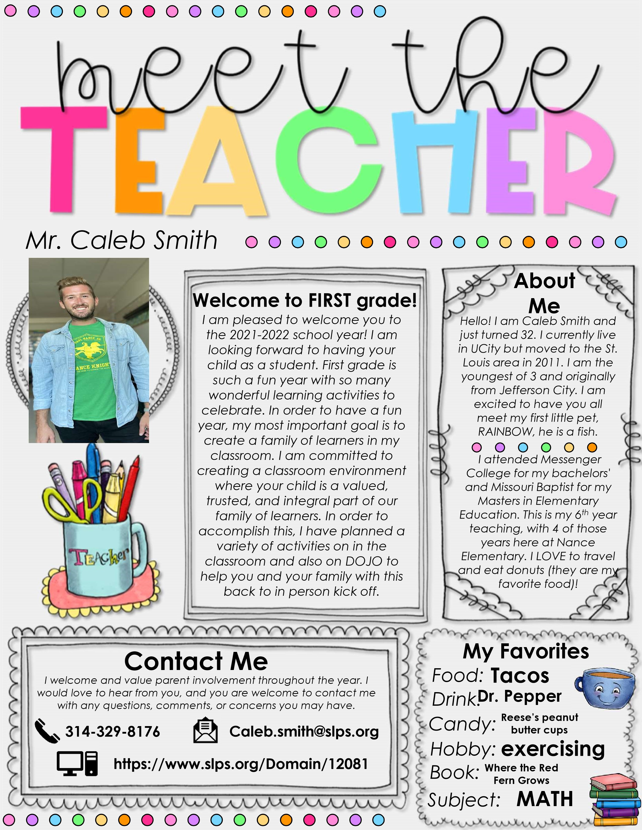



**Social Studies**

I am pleased to welcome you to the 2022-2023 school year! I am looking forward to having your child as a scholar. First grade is such a fun year with so many wonderful learning activities. In order to have a fun year, my most important goal is to create a family of learners in my classroom. I am committed to creating a classroom environment where your child is valued, trusted, and integral part of our family of learners. In order to accomplish this, I am planning a variety of activities in my classroom. I will have homework each week. Your scholar will leave my class with a wealth of information. . I am in room 106 and please be assured I will give your scholar my wisdom and knowledge.







**I am very happy to be here. I am looking forward to teaching the following subjects of English, Math, Science and my favorite is Black History/Social Studies. I have many manipulatives for STEM activities. I also have a love of art and art projects.**

***Ms. Denise Bass***

**Hello! I am Denise Bass and this will be my second year at Jefferson. I am a product of University City High School and a graduate and University of Missouri-St. Louis. I have taught many students from kindergarten to high school. I have worked with children of special needs.** Whatever the subject is, I can use my ‘superpower’ of education!

**Afr. Am. Studies**

**Cooking**

**https://www.slps.org/Domain/15645**

**Denise.Bass@slps.org**

**314-518-0874**

**Twizzlers/Nubs**

**: Sprite/7up**

**Chinese**

